THE CHRONICLE

St John’s Kirk - Perth

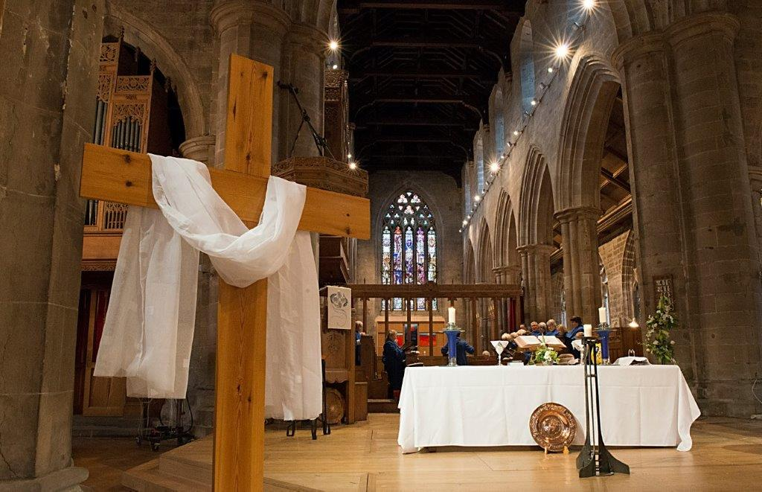

No 369 March 2018

The Manse of St John’s and St Leonard’s in the Fields,
Ferntower, Kinfauns Holdings, Perth PH2 7 JY
jmurdoch@churchofscotland.org.uk 01738 628378

Love
Love bade me welcome: yet my soul drew back, Guilty of dust and sin.
But quick-ey'd Love, observing me grow slack,
From my first entrance in,
Drew nearer to me, sweetly questioning,
If I lack'd anything.
A guest, I answer'd, worthy to be here:
Love said, You shall be he.
I the unkind, ungrateful? Ah my dear,
I cannot look on thee.
Love took my hand, and smiling did reply.
Who made the eyes but I?
Truth Lord, but I have marr'd them: let my shame
Go where it doth deserve.
And know you not, says Love, who bore the blame?
My dear, then I will serve.
You must sit down, says Love, and taste my meat:
So I did sit and eat.

George Herbert
3 April 1593 – 1 March 1633

Dear Friends of both Congregations

On the threshold of Easter, as St David’s Day, the first day of the new month, leads us into March and we are drawn ever closer to Holy Week, the lines above of Welsh-born poet, orator and Priest George Herbert, are not only suitably relevant but also are inspirational and of real help, aren’t they?

In these remaining weeks of Lent, during March especially, inspired also by other ‘March saints’ of the past such as Thomas Cranmer, died 21 March 1556, Perpetua and Felicity, martyred 7 March 203 and also by the 7th century saint, Cuthbert of Melrose Abbey and later Lindisfarne, died 20 March 687, we find great strength from their example in a world where faith is often side-lined by those who say man has come of age and there is no need for God

As Christian people we chart a different course and follow Him who conquered death and lives today. We are those who have responded to the Invitation to dine as Guests at the Table and to take the narrow path to follow Christ. We are the pilgrim-people and we walk by faith. Faith seeking understanding as St Anselm [1033 – 1109] taught.

Our faith needs nurture, so I invite you to any or all of the Holy Week Services and hope very much that the great truths and traditions of Easter will come alive for you and that you will be encouraged, sustained and guided into new avenues of Christian service and faith. Yes, be encouraged as we share one with another; for Easter is a time of renewal and of of renewing Vows of our allegiance to Him ‘who was conceived by the Holy Spirit, born of the Virgin Mary, suffered under Pontius Pilate, was crucified, dead and buried. He descended into Hell. The third day He rose again from the Dead…..’. This is phenomenal, life-changing and worth the risk of trust!

That Third Day makes all the difference- let us hold fast, committed and willing to share this glorious Gospel with everyone.
Christ has died, Christ is risen, Christ will come again. This is our faith, a victorious one- don’t hold back!

My very best wishes for all that Easter stands for and will ever mean.
Happy Easter to you and all whom you love.

John

Collect of St Cuthbert

Recited on 20th March every year in Durham Cathedral

Almighty God,
who called your servant Cuthbert from following the flock
to follow your Son and to be a shepherd of your people:
in your mercy, grant that we, following his example,
may bring those who are lost home to your fold;
through Jesus Christ your Son our Lord,
who is alive and reigns with you,
in the unity of the Holy Spirit,
one God, now and for ever.

Amen

Holy Week Services – All Are Welcome

Palm Sunday Sunday 25th March
9 30 am in St John’s Kirk
Family Service

11 15 am in St Leonard’s in the Fields
Family Service with the Sacrament of Holy Baptism

Monday 26th March at 7 pm in St John’s
Easter Prayers and Musings

Tuesday 27th March at 7 pm in St Leonard’s
Easter Readings and Poetry

Wednesday 28th March at 1 pm in St John’s
Easter Singing

Maundy Thursday Thursday 29th March at 7 pm in St Leonard’s
Holy Communion

Good Friday 30th March
Walk of Witness
10 30 am until 11 30 am from St John’s

Good Friday 30th March at 12 noon
Three Hour Liturgy : Journey to Calvary

Good Friday at 7 pm in St John’s
Tenebrae

Easter Day : Sunday 1st April

8 am : Early Service on South Inch

9 30 am : Morning Service
Easter Day Holy Communion
in St John’s

11 15 am : Morning Service
Easter Day Holy Communion
in St Leonard’s in the Fields

All are welcome to come to the Lent Discussion Groups for St John’s Kirk of Perth and St Leonard’s in the Fields :

Monday Evenings at 7 pm On the Third Day : York Courses Material

Remaining evenings:
Monday 5th March : Peter Thomson in St Leonard’s Vestry

Monday 12th March : John Wylie in St John’s, Knox Chapel

Monday 19th March : Alex Stewart in St Leonard’s Vestry

SESSION CLERK UPDATE
Dear Friends,
Well it has been a hectic few weeks on either side of New Year.

Many of you will have seen the Stonemasons at work in their “cherry picker” before Christmas as they checked the stonework of the Kirk. There were a few things that needed dealt with immediately, including some unsecured stones, and they were also getting up close to really inspect the stonework and see what further work will be required. As of mid February, we are still waiting for their final report, but we expect that it will identify work of around £900,000. As we all know, old buildings do require ongoing work to keep them in good condition.

As I mentioned in my letter in the November Chronicle, our Plan for the Mission of St John’s was submitted to Presbytery in October as a preliminary draft, with more work to be carried out over the winter. At the same time we asked them to give us approval in principle to request the Trust for St John’s to begin raising funds including for the stonework, for the Brides Door and for the long anticipated work at the West Door when the Council start to work on the City Hall in 2019. In total it will require £1.7 million.

However, whilst Presbytery quite liked our Plan for Mission they were concerned that we continue to have a Revenue Deficit every year. That is another way of saying that we have to spend more than we can bring in from Congregational Giving and income from concerts etc. In 2017 the shortfall was £43,000. Fortunately St John’s has investments that are well managed which covered the shortfall. But we cannot rely on the stockmarket always covering our deficit and we need to do all we can to reduce it.

At the end of January representatives of the Kirk Session, the Trust for St John’s and the Friends of St John’s met with representatives of Presbytery and of the General Trustees. We presented them with a fuller version of the Plan that confirmed that Session take the issue of our deficit very seriously.

The revised Plan sets out:
- What we already do about Mission and what more we will do over the next couple of years
- The action that we will take to reduce our deficit (we hope to say more about that in the next Chronicle)
Because Presbytery accept the position we have set out in our Plan and the action we will be taking, it is now likely that at its meeting in March, Presbytery will give us the green light for the Trust to start fund raising for the stonework etc. The Trust has already generously agreed that it will raise all the funds needed for the work, and this will allow the Congregation to concentrate on reducing its deficit.
5
Like most Church of Scotland Churches, St John’s is held in Trust by the General Trustees. For several years we have been speaking to the General Trustees about the additional costs involved in looking after a historical church like St John’s. Other historical churches have also joined this conversation as they have very similar problems to us. One idea that has come from that conversation is the possibility that there might be advantages in transferring ownership of a historical church like St John’s to a new Trust. Whilst the idea has still to be explored in any depth, we have agreed to at least take part (along with our own Trust for St John’s) in discussions to see whether there is any merit in the idea. The Kirk would of course continue to be the City Kirk and a place of worship. So if you hear mention of the possibility that ownership of St John’s might change, it will be in that context and much work remains to be done before any decisions can be made.

St John’s is greatly blessed to have both a Trust to raise funds to look after the building, and to have had the generosity of previous generations to have created investments that support us, but if we are to be able to see St John’s flourish in the future as we all would wish, we will need to reach out together to create that future.
Bill Wilson, Session Clerk
Please note following dates:

Annual Stated Meeting: Sunday 18th March 10.30am Knox Chapel

March Presbytery Conference Session

PLANNING FOR THE FUTURE
Given the truth and relevance of Jesus and our responsibility to show/share God’s love in our fast-changing society when there will be many fewer ministers

What are we to do?
How will it affect our congregation?

Time for discussion and reflection, prayer and next steps.

All are welcome
In Kinross Church on SAT 10 MAR
(tea/coffee at 9.30am) 10.00am-noon
A paper - which can be shared with anyone - to help prepare for this will be sent a week before

FELLOWSHIP CLUB
Our last meeting of the season will be on Tuesday 13th March at 2pm in the Church when Marjorie Clark will speak about “Mary Slessor”. As usual this meeting is open to anyone in the Congregation to come along and join us.

The Annual General Meeting will be held in April.

A Coffee Morning will be held in the Church late spring/ early summer and the date will be announced in the Order of Service.

Wilma Malcolm
Hon Secretary.

CHRISTIAN AID EVENTS
Taybridge Cross: Sponsored Walk Saturday 21st April 2018

Coffee Morning: North Church Hall Saturday 12th May 2018
10am – 11.30am

Christian Aid Week: 13th – 19th May

Anyone willing to help at the Coffee Morning or wishing to contribute to Stalls – Cake & Candy, Books, Bric a Brac contact Lorna (Choir) on 01738 632206

Lorna Ferguson
Christian Aid Representative

CrossReach

The first CrossReach News of 2018 focuses on ‘Services to Older People’, however the Scottish Government has officially named 2018 ‘The Year of Young People’.

This inter-generational approach has been well illustrated by the WOW Initiative (Wee Ones at Whinnieknowe) inspired by a Channel 4 Documentary ‘Old People’s Home for Four Year Olds’.
Bringing generations together helps to combat loneliness and improve health and well being by bringing energy, knowledge and enthusiasm into other’s lives.

Emma Mackay describes another CrossReach project.
“Matthew’s parents have a long history of drug use and Matthew suffered both neglect and abuse under their care. Having been removed from his parents, Matthew’s aunt and uncle were eventually granted permanent custody of him. He initially struggled to talk about his emotions and rarely discussed his birth parents or what had happened to him.

It has taken gentle, persistent and consistent therapeutic intervention at Sunflower Garden in Edinburgh for Matthew to explore his trauma in a safe space, at his own pace, and in his own way. This also appears to be affecting other areas of his life as his carers and school are beginning to notice an increase inn his ability to deal with difficult emotions.”

The range of projects undertaken by CrossReach is immense. Please take a copy of ‘CrossReach News’ or the Prayer Diary to see ways of engaging with this work.

Fairtrade Fortnight 26th February – 11th March

Brexit is constantly in the news with the UK wanting to negotiate the best trade deals.

‘Fairtrade’ aims to get trade justice for the millions of poor farmers around the world who produce many of the goods we love- tea, coffee, bananas, cotton, flowers, among them. Often they do not earn enough to feed their families. However many are coming together to demand change and are working together to close the door on exploitation so that they may transform their communities and improve their standard of living.

Please look at the Fairtrade display at the West Door.

PERTH & KINROSS FOODBANK

This is a sad news/good news report. You will have seen in the local press that Les Paskin has died. Les was our first Project Co-ordinator, a dedicated Christian, whose energy and drive got the Foodbank up and running. Although he had retired he still popped in to see us. We will miss him.
The good news is that following press reports that the Foodbank was likely to have financial difficulties over the next year or two due to rental, staffing and other running costs we have been allocated 3 years’ funding by Perth & Kinross Council. Members of the public have also been generous in their support since the Press Report so we will be able to continue our work for the next year or two as unfortunately demand is not going down!
Anne Chatt (Foodbank Representative)

EVENTS IN ST JOHN’S

DATE | TIME | EVENT
March 3rd | 1p.m. | Organ Recital - Stuart Muir, St Paul's Cathedral Dundee with Matthew McAllister (Guitar) *
March 7th | 7.30p.m. | Perth Chamber Music Society -Schubert Ensemble **
March 18th | 3pm | Strathearn Piano Trio *
March 25th. | 7.30p.m. | Perth Choral Society - Music by Vivaldi and Bach **
April 14th | 11a.m. | Scottish Reformation Society Conference ***
May 17th- 26th |  | Perth Festival of the Arts - Various Events **
May 29th | 7p.m. | National Youth Choir of Scotland - Perth Boys Choir #

Tickets: * Free Admission
** Available from Horsecross
*** N/A
# Tickets at Door

KIRK STEWARDING
We welcomed all of 1370 people into St John’s last year. While I appreciate that numbers are valuable it is obviously what people take away with them that is important. Some may never come back again but hopefully their time with us might just re light the inner flame which will bring them nearer to God.
Others will look round, admire the surroundings and head off for lunch. It is not up to us to judge why people come in but just the fact of having the open door is so valuable.
Of course the doors cannot be left open without someone being in attendance. Unfortunate but necessary.
We have a wonderful band of volunteers who try their best to ensure that this can be done. This year we aim to open for Holy Week ( between the hours of 11am and 3 pm.) These hours will continue until May when we resort to our usual times of 10 am to 4 pm. ( May to the beginning of October)
August is our busiest month and we aim to extend our opening into the evening. Perhaps from 6pm to 8 pm. It is worth a try.
As said, all of this cannot happen without the ongoing support and dedication of our volunteers. To all of them and on behalf of St John's , I extend my sincere thanks. Where would we be without them.
However should anyone wish to join us , believe me, you would be extremely welcome. You do not need to know all the history of St Johns, thought this is extremely interesting, but simply being able to present a welcome to all who come through our doors is both a pleasure and a privilege in itself.

Kay Morrison.

Our Church Family

Baptism
“Let the little children come to me, and do not hinder them, for the kingdom of heaven belongs to such as these”

Sunday 24th December 2017 JESSICA RUBY MACASKILL

Deaths of Church Members

Jesus said, “I am the Resurrection and the Life.”

October Pamela Wilson D90

December James Eccleston D21
Ella Robertson D90
Phyllis Livingston D83

January Pat MacDonald D90 Mary MacGregor D101
Winifred Meiklem D52
Ellizabeth Pollock D90

February Emily Coles D72

New Members
Rosemary Ramsay - Certificate of Transference from Orkney
Miss Kate Barbour - Certificate of Transference

Members on the move
Jim & Gloria Smith moved to Taymount Terrace, James & Brenda Calderwood moved to Bonhard Rd, Scone, Rona Munro moved from Bridge of Earn to Jeanfield Rd, Perth and Jessie Thompson moved to Kincarrathie House

And finally…….
Spring is just round the corner and the nights are getting longer. Winter is drawing to a close although we need to remember that March can “come in like a lamb and go out like a lion” (or vice versa!)

We have also reached the most important period in the Christian year – Easter – a time of reflection and denial. The Lent discussion groups can help us with the former. We also have a chance whilst giving up something for Lent to support Water Aid (see next page) by filling up jars with our change.

Happy Easter

God Bless
AnneChatt
Editor

JARS OF GRACE/JARS OF CHANGE

At this time of year, many Christians are considering what to give up for Lent. But imagine having to give up school and your hopes for the future.

This is the reality for many children around the world who don’t have clean water or toilets at school. But with the help of churches across the UK, it could soon change. By giving something up this Lent, your congregation can make sure that Urusa (pictured below) and children like her don’t have to give up on the life they dream of.



Please during Lent can you collect your spare change in a jam jar- perhaps having it on your kitchen table- and raising funds for Water Aid. There are small ‘sleeves ' available in both Churches which can be placed inside your jar. When you feel you have collected all you can, return the jar to Church by Sunday April 15th.

The next issue of the Chronicle will be available on 3rd June 2018. Anyone in the congregation is welcome to submit contributions for the Chronicle but all articles will need to be with me by Tuesday 22nd May at the latest. N.B. If you have internet access, articles can be emailed to me as an attachment at my email address which is anneski60@blueyonder.co.uk

(Front page picture – David Morrice)

CONTACTS
MINISTER Rev’d John Murdoch, Ferntower, Kinfauns Holdings, Perth
PH2 7JY Mobile 07578558978 Tel 628378
ASSOCIATE MINISTER Rev’d Alex Stewart, Tel 566675
Email alex.t.stewart@blueyonder.co.uk
SESSION CLERK Mr Bill Wilson,, Rockdale House, Kinfauns Tel 637743
DEPUTY SESSION CLERK Miss Kay Morrison, 124 Burghmuir Rd, Perth Tel 447123
TREASURER Mrs Lorna Ferguson, 3 Feus Place, Perth PH1 2BH Tel.632206
FINANCE CONVENOR Mr Robert MacFarlane, 5 Mount Blair View, Perth Tel 634177
GIFT AID CONVENOR Miss Wilma Malcolm, 20 Burghmuir Road, Perth Tel.622807
DIRECTOR of MUSIC Mr Howard Duthie, MA, FRCO Ceol Mor Tel 583557 . Woodend Almondbank, Perth email- hduthie@dsl.pipex.com
CHOIR DIRECTOR Mrs Marjory Watson
CHURCH OFFICER Mr Doug Pringle Mobile 07748601759 Tel 637601
BLDG SERV. OFFICER/ Mr Jim Withers Mobile 07853136560 Tel 01821
DEP. CHURCH OFFICER 650380
ROLL KEEPER Mrs Aileen Morrice, Tel 582137
aileen.e.morrice@btinternet.com
FELLOWSHIP CLUB Miss Wilma Malcolm, 20 Burghmuir Road, Perth Tel.622807
FLOWER CONVENOR Mrs Jean Taylor, 14 Bleachers Way Huntingtowerfield
Tel 582303
EVENTS COORDINATOR Miss Wilma Malcolm, 20 Burghmuir Road, Perth Tel.622807
PERTH ACTION OF
CHURCHESTOGETHER Mrs Marjory Wylie, 19 Cleeve Drive Perth Tel 245362
CHRISTIAN AID Mrs Lorna Ferguson, 3 Feus Pl, Perth PH1 2BH Tel.632206
"CHRONICLE" EDITOR Ms Anne Chatt, 105 Nimmo Ave, Perth PH1 2PU Tel 643745
e-mail anneski60@blueyonder.co.uk
KIRK OFFICE Tel 633192

THE CHURCH IS OPEN DAILY from May to September between 10am and 4pm
- Morning Service is held on every Sunday throughout the year, currently at 9.30am, with the first and third Sundays of each month being occasions when the Sacrament of Holy Communion is celebrated during Morning Worship. Holy Communion is also celebrated on Christmas Day, Ash Wednesday, Maundy Thursday, Easter Day and Pentecost.
- The Minister then takes the St Leonard’s in the Fields Morning Service at 11.15am
In addition, a short service is held every Wednesday at 1pm in the Knox Chapel.

In order to enable as many people as possible to share in worship, there is a ramp at the south door for wheelchair and pedestrian access; an audio induction loop system is in operation and large print hymn books are available at the door.
The Minister is happy to be contacted by telephone as above or by email – jmurdoch@churchofscotland.org.uk

Kirk website is www.St-Johns-Kirk.co.uk
Charity Reference No SC017132

