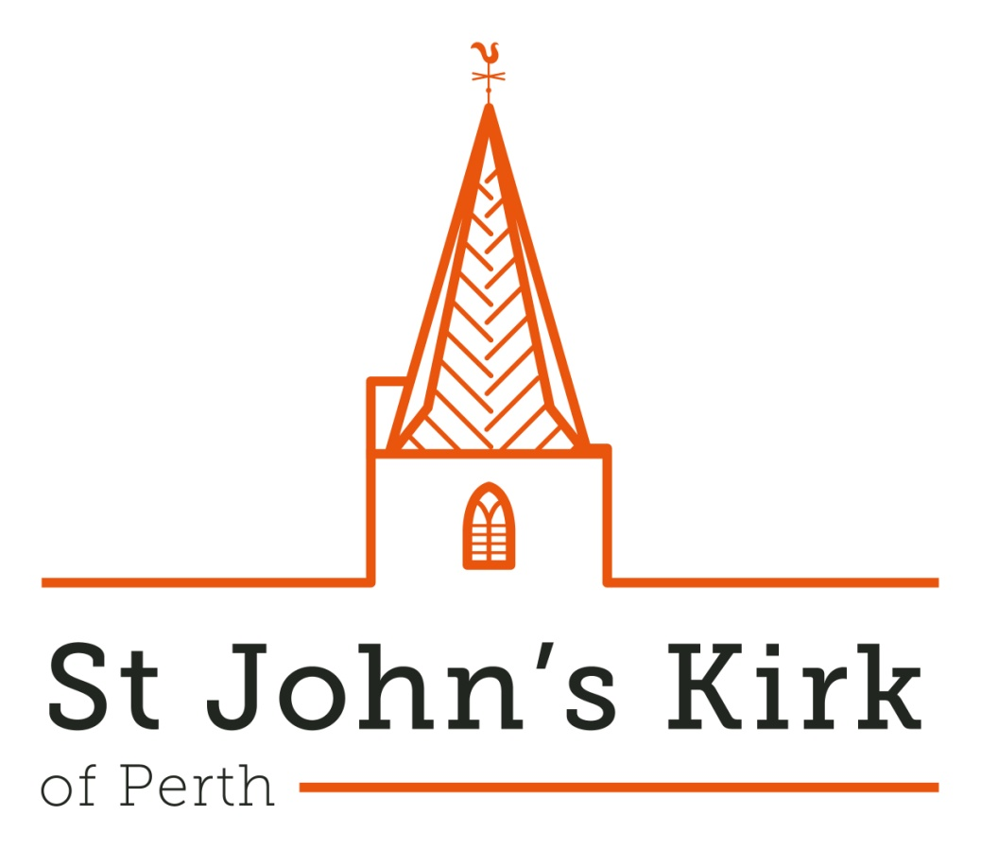

**St John’s Music, Sat 2 November 2024, 1.00 pm**

**Organ Recital by Colin Andrews**

**(First Presbyterian Church, Franklin, Indiana, USA)**

**Joseph Bonnet (1884-1944)**

Variations de Concert (1906) Op. 1

**Johann Sebastian Bach (1685-1750)**

*from the Leipzig autograph*

"Allein Gott in der Hoh sei Ehr" BWV 662

Passacaglia and Fuga in C minor BWV 582

**Herbert Howells (1892-1983)**

Two Psalm-Preludes:

No.1, Set 1 (1914) - No. 3, Set 2 (1939)

**Ludwig van Beethoven (1770-1827)** *transcr. Colin Andrews*

Adagio cantabile from Piano Sonata No. 8

in C minor Op. 13 ("Pathetique")

**Olivier Messiaen (1908-1992)**

"Dieu Parmi Nous" from

"La Nativite du Seigneur" (1935)

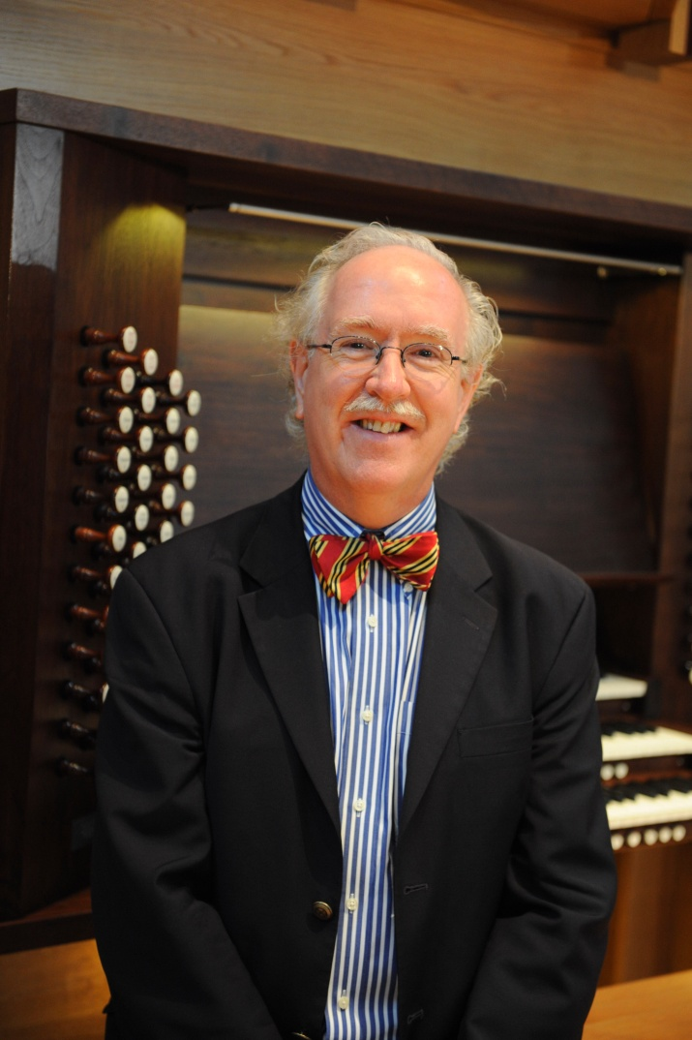

*Forthcoming dates:*

*\*Sun 3 Nov 2024, 3.00 pm* Quartetto Nous*

*Sat 7 Dec 2024, 1.00 pm Ischico Veizel (piano)*

*Sun 15 Dec 2024, 3.00 pm Perthshire Brass with Scottish Police and Community Choir*

*Sat 1 Feb 2025, 1.00 pm Jordan English (organ)*

*Sun 16 Feb 2025, 3.00 pm Jambouree Choir*

*Sat 1 March 2025, 1.00 pm James Lind (guitar)*

*Free admission (retiring collection) at all events except *Nov 3* (details at* [www.perthchambermusic.org.uk](http://www.perthchambermusic.org.uk) )

**Colin Andrews: short biography:**

Colin Andrews was born in Bristol England. He studied at The Royal Academy of Music in London and at The Conservatoire de Muisque in Geneva, Switzerland. His principal Professors were Lionel Rogg and Dame Gillian Weir.

Colin Andrews was a prizewinner at both the 1980 & 1982 Dublin International Organ Competitions in Ireland. In 1993, The Royal Academy of Music in London bestowed an Associateship upon him in recognition of his distinguished performing career.

Mr. Andrews has toured worldwide as a concert organist, undertaking multiple tours of Asia, Europe and trans-continental tours of Russia. He has performed in all of the major concert halls in Asia, including Suntory Hall, Tokyo, Esplanade Theaters-on-the-Bay, Singapore, Beijing National Center for the Performing Arts, Shanghai Oriental Arts Center, Sydney Town Hall, Australia, Auckland Town Hall, New Zealand etc. Other concert venues have included The Royal Festival Hall, London, King's College, Cambridge, The Cathedral of Notre-Dame, Paris (three appearances), The Moscow Conservatoire, The St. Petersburg Philharmonic Hall & Mariinsky Theatre Concert Hall, St. Petersburg, Russia, The National Convention of The American Guild of Organists, plus, leading halls, Cathedrals & Churches throughout Europe, The United States of America, Siberia, South Africa & South America.

Mr. Andrews is an active teacher & lecturer and has been a faculty member of both East Carolina University and Indiana University. He has given lectures and masterclasses worldwide.

Colin Andrews has recorded 14 compact discs for the Naxos, Gothic, Loft, Priory & Zig Zag labels and has also recorded more than 30 programmes for the BBC in England. He has also appeared on television and radio in Japan, Belgium, Russia, Poland and New Zealand. He is frequently featured on the worldwide radio programme "Organroxx".

Andrews is one of only five organists in the world to have recorded the complete organ works of Olivier Messiaen. In 2012, Mr. Andrews was named a "Membre d'Honneur" of the "Association Grand Orgue Trinite Messiaen" based at Messiaen's church, "l'Eglise de la Sainte Trinite" in Paris. His recordings have been widely acclaimed; in 2012, the magazine, "Christianity Today" listed Mr. Andrews's recording of Messiaen's "l'Ascension" & "Messe de la Pentecote" in the top 10 recordings of Sacred Music. In 2021/2022, tours include France (2nd. appearance at La Madeleine, Paris), Hungary, Denmark, Italy & Colorado, North Carolina, Chicago (complete performance of "Livre du Saint Sacrement" by Messiaen for the AGO) & Virginia, USA. He was also visiting Professor in Organ at Florida State University during the fall of 2021. In 2022, Mr. Andrews toured Australia and Europe giving 30 concerts and teaching in Sydney whilst continuing his visiting Professorship at Florida State University. In 2023, Mr. Andrews continued as visiting Professor at both Florida State and East Carolina Universities in addition to recitals and masterclasses in Australia, New Zealand, UK, US, Norway, Finland, Belgium, Italy, Latvia and Hungary. Plans for 2024 include tours of Australia, Asia, Poland, Norway, UK, Italy, Finland, Denmark, Hungary, The Netherlands and Scotland, including his tenth visit as a faculty member of the Oundle Summer School for young organists in the UK. He will also return to Florida State University once again as visiting Professor and continue his role as Director of Music at First Presbyterian Church in Franklin, Indiana.